JAMES CREEK ARCHAEOLOGICAL FIELD SCHOOL

June 9 to June 25, 2003


Prehistoric Archaeology in the Carmel Valley:

Investigations of the James Creek Bedrock Mortar Site
Sponsored by California State University, Monterey Bay, Institute for Archaeology
In collaboration with Ohlone Costanoan Esselen Nation

COME TO CAMP
The prehistoric site under consideration is situated on a bend of the James Creek in a rural portion of the Carmel Valley of Central California. Numerous bedrock mortars are present and it will be our task to survey, document, and conduct enhanced methods of excavation at the site. Student assessment will be based on assigned exercises, field notes, project participation, and team effort.
SBSC 341 (CRN 35087)
This six unit course will provide students the opportunity to learn professional archaeological field techniques, including field survey, site mapping, excavation, artifact identification, note preparation, preliminary artifact processing, controlled data recovery, and stratigraphic profiling. Fees are calculated at $114.00 per unit. (Prerequisite: Permission from Instructor)
Contact: Instructor, Susan Morley susan_morley@csumb.edu

Voice: (831) 645-9162; (831) 582-4364

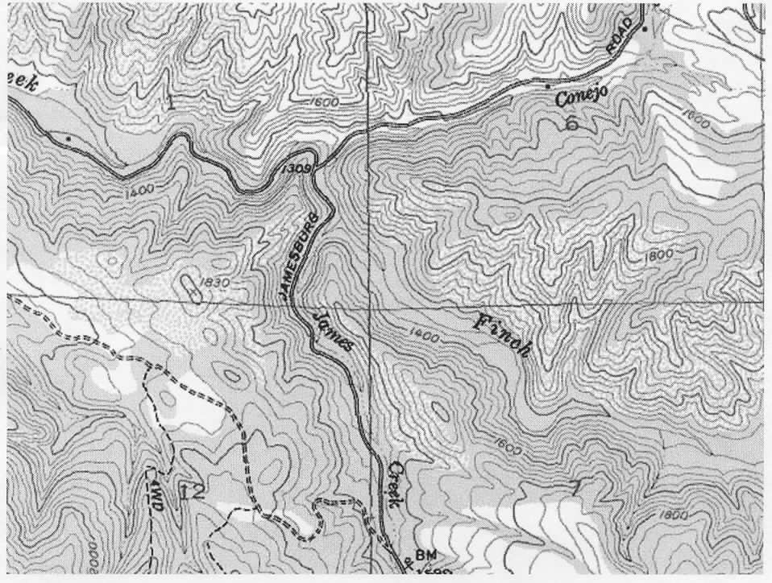

Evening Lectures
Various specialists in California archaeology will present evening lectures, as will California Indians from local tribes who will be working in collaboration with this investigation. We are fortunate and honored to have the guidance of the Esselen Nation. Budding archaeologists, indeed all archaeologists, are encouraged to develop good working relationships with the people whose heritage they are investigating.

Come to Camp
This is a rare opportunity to work and camp on an archaeological site. A creek borders this bedrock mortar site in a beautiful natural setting. June weather should be ideal for working and enjoying time outdoors. The owners of the property have invited us to conduct this field school and they look forward to our study. These folks have extended their hospitality to us and have invited us to camp onsite. Students will be responsible for their own food and camping gear. Students who may not wish to camp may find lodging in nearby Carmel Valley Village.

See http://extendeded.csumb.edu/DistribLearning_reg.pdf for Extended Studies Registration Forms


